VetMedics Inc.
123 Cherrywood Dr.
Fishkill, NY, 12524
(845) 202-7200
www.VetMedics911.com

CLIENT INFORMATION FORM
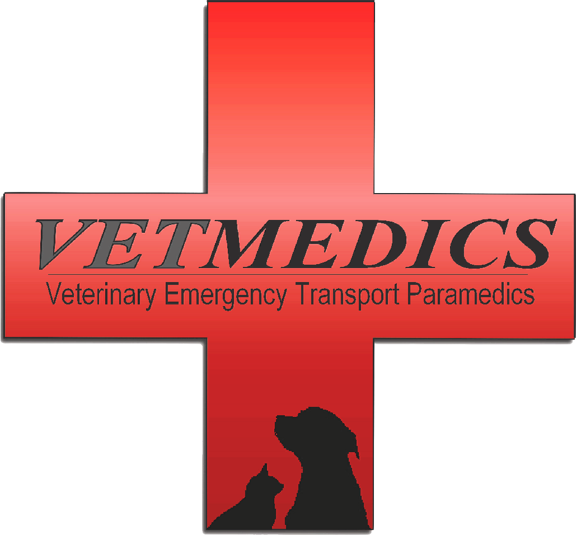

This agreement, dated is made between VetMedics Inc. located at 123 Cherrywood Dr. Fishkill, NY.12524, referred to as “VetMedics” and the Client.
Please fill out the following:
Owner’s Last Name: First Name:
Street: Apt#:
City, State: Zip:
Home Phone: Emergency Phone:___________________________
Work Phone:
Email:______________________________________________________________________________________________

PET INFORMATION:
Pet Name: _______________________________ Species: _______________________ Age: ___________
Breed: _______________________ Sex: M / F Neutered: Y / N Color: _________ Weight__________

PRICING:

CASH DISOVER: _____ AMEX______ VISA: MC: ______
Credit Card #:__________________________________________________ Security Code:______________
Expiration Date:_______________________________ Billing Zip Code: __________________

PLEASE NOTE: PERSONAL CHECKS ARE NOT ACCEPTED AND PAYMENT IS DUE WHEN SERVICED ARE RENDERED. A CREDIT CARD IS REQUIRED FOR REQUEST OF EMERGENCY SERVICES AND A DEPOSIT OF NO LESS THAN $175 WILL BE MADE. VETMEDICS RESERVES THE RIGHT TO CHARGE SAID CREDIT CARD AT COMPLETION OF SERVICE. PLEASE NOTE, PRICE GIVEN MAY VARY DEPENDING ON SERVICES NEEDED AND IS AN ESTIMATE ONLY. ( ex: additional oxygen, medications, etc ) . OWNER HAS 15 MINUTES FROM REQUEST OF DISPATCH TO CANCEL. CANCELLATION OUTSIDE OF 15 MINUTES WILL INCUR A $175 FEE.

CLIENT SIGNATURE: __________________________________________________________________________

Non-Emergency Transport
[ ] ONE WAY TRANSPORT SINGLE TEAM MEMBER UP TO 25 MILES $ 95.00 + TX
[ ] RETURN TRANSPORT SINGLE TEAM MEMBER $ 40.00 +TX
[ ] WAIT FEE PER HALF HOUR $ 25.00 + TX

Emergency Transport

[ ] ONE WAY TRANSPORT UP TO 25 MILE RADIUS SINGLE TEAM MEMBER $ 195
[ ] ONE WAY TRANSPORT OVER 25 MILE RADIUS SINGLE TEAM MEMBER $295 + (dependent on distance )
[ ] ADDITIONAL TEAM MEMBER $ 130.00
[ ] WAIT FEE PER HALF HOUR PER TEAM MEMBER $40.00

***PLEASE NOTE THAT MILEAGE IS CALCULATED FROM LOCATION OF VETMEDICS IN FISHKILL, NY

Additional Services

[ ] OXYGEN PER HALF HOUR $65.00 [ ] INFUSION PUMP FOR IV FLUID THERAPY $85.00 [ ] MEDICATION ADMINISTRATION $25.00
[ ] WOUND DRESSING/ CLEANING $45.00
[ ] CPR $200.00

*** YOU HERBY THE CLIENT AUTHORIZE CPR IF NECESSARY: YES:_____ NO:_____

CLIENT SIGNATURE:___________________________________________________

Home LVT Visit*
**PLEASE NOTE ALL TREATMENTS/MEDICATIONS HAVE BEEN AUTHORIZED BY PATIENT/OWNERS VETERINARIAN. VETMEDICS DOES NOT DIAGNOSE ANY ILLNESS OR PRESCRIBE ANY MEDICATIONS.

[ ] FLUID THERAPY, DIABETIC MAINTENCE, MEDICATION ADMINISTRATION $95.00

[ ] NAIL TRIMMING, EAR CLEANING $45.00
** EACH ADDITIONAL PET IS $5

*ADDITIONAL FEE FOR OVER A 25 MILE RADIUS

In Home Euthanasia Services
[ ] $350 + ( Cost will vary dependent on weight of patient )
[ ] Private cremation with remains returned to owner ( Cost varies dependent on weight of patient )
[ ] Communal cremation with no remains returned to owner ( Cost varies dependent weight of patient )

ESTIMATED TOTAL $ _________
Client Affirmation
You, the client understand, agree and affirm that the above information must and is accurate in that it may be relied on by VetMedics, its employees, agents and veterinary professionals in the treatment of the above mentioned pet or animal
Initial:__________
You, the client, authorize VetMedics to transport the above-mentioned pet or animal and to use all reasonable precautions against injury, escape or death, and You, the client, release and hold harmless VetMedics, its employees and agents for any injury, escape or death.
Initial:__________
You accept full and complete responsibility for any errors or omissions and hold harmless VetMedics, its employees, and agents for any errors or omissions arising before, during or after the transport of the above mentioned pet or animal.
Initial:__________
You, the client do hereby remise, release, acquit, satisfy, and forever discharge VetMedics, its employees or agents of and from all manner of action(s), cause(s) of action, suits, debts, sums of money, accounts, controversies, agreements, promises, damages, judgments, executions, claims and demands whatsoever, in law or in equity, which You shall or may have, by reason of any matter or cause.
Initial:__________
You, the client understand and agree that VetMedics Inc. provides pet transportation only and does not provide any diagnosis or prescriptions of any kind. Upon request by You, the Client, veterinary professionals are available for an additional fee to accompany the above mentioned pet or animal during transit to provide any medical or veterinary assistance.
Initial:__________
You the client herby authorize VetMedics to allow photography and or video footage to be taken and used for social media advertising purposes on Facebook, Instagram and company websites. These sites are www.vetmedics911.com , www.facebook.com/vetmedics , vetmedics911pets and www.thewalkingdog.co
Circle: YES NO INITIAL:___________

After carefully reading the above, I have signed in agreement.
ACCEPTANCE: DATE:

